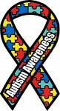
ALL ABOUT AUTISM

CAR, TRUCK, MOTORCYCLE SHOW & CRUISE-IN
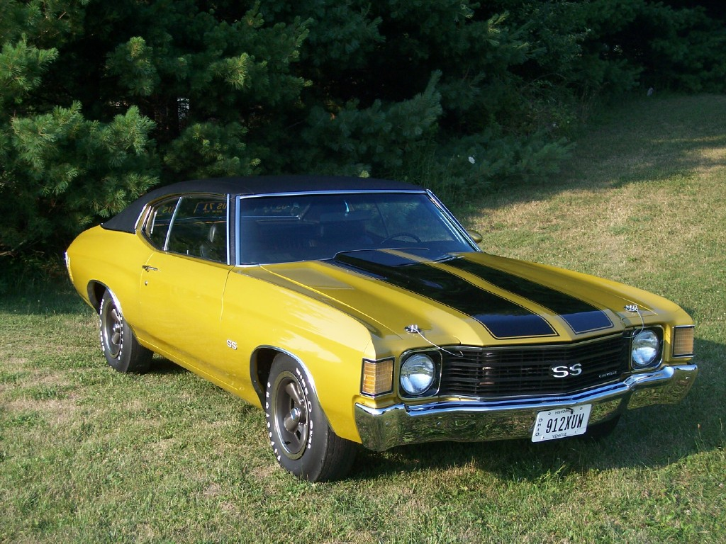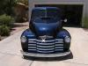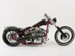

THIRD ANNUAL EVENT

100% OF PROCEEDS TO BENEFIT CHARITIES
FOR CHILDREN WITH
AUTISM SPECTRUM DISORDERS

WHEN: AUGUST 15, 2009 - 1:00 P.M. to 5:00 P.M. Registration Fee is $10.00

Registration begins @ 11:00 A.M. T-Shirts & Goodie Bags to the 1st 250 Registrants

WHERE: 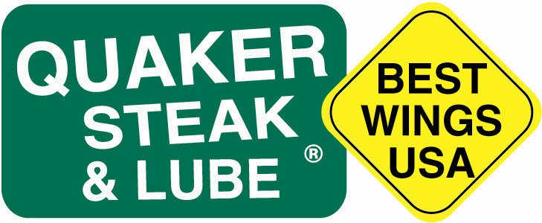8500 Lyra Drive, Columbus Ohio
www.quakersteakandlube.com
At the Intersection of Polaris Parkway and Lyra Drive

SPONSORED BY:

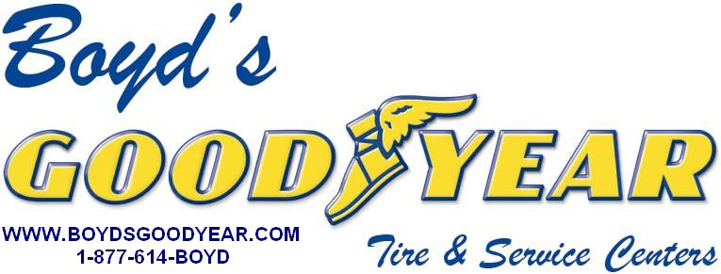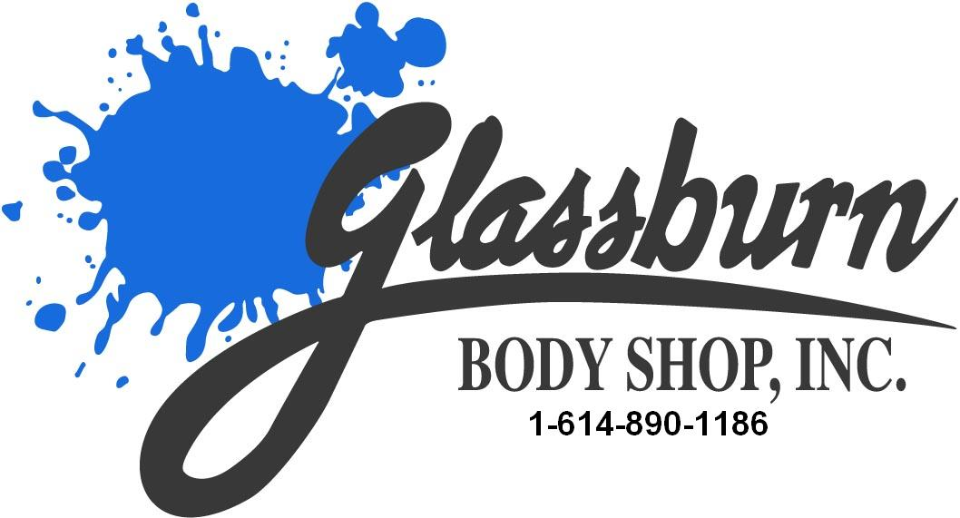

Music by “Six Pack Theory”, DJ, Karaoke, T-Shirts (1ST 250), Trophies (Top 50 Cars and Trucks. Top 20 Bikes) Dash Plaques (1ST 250), Car Raffle, Silent Auction, Many Great Raffle Items, Great Food & Drinks, Peoples’ Choice Judging, Kids Activities, and Much More
MANY GREAT SILENT AUCTION AND RAFFLE ITEMS
* TO BE A SPONSOR, A VOLUNTEER, TO MAKE DONATIONS, OR HAVE ANY QUESTIONS ABOUT THE EVENT* PLEASE CALL MIKE HOOVER AT 614-580-7300 OR SEND AN E-MAIL TO
BOYDSGOODYEAR@AOL.COM
Or visit WWW.BOYDSGOODYEAR.COM
DISCLAIMER: BOYD’S GOODYEAR , GLASSBURN’S BODY SHOP , AND QUAKER STEAK AND LUBE, ARE
NOT RESPONSIBLE FOR ACCIDENTS, AND / OR LOST, STOLEN OR DAMAGED ITEMS.
“MAKE A DIFFERENCE IN A CHILD’S LIFE”

WE’D LIKE TO THANK THE FOLLOWING SPONSORS

BOYD’S GOODYEAR TIRE & SERVICE
GLASSBURN BODY SHOP
POSTNET OF WESTERVILLE
MAXTOWN MOTORS
WESTERVILLE EXPRESS
COLUMBUS DISTRIBUTING
SIX PACK THEORY
WORTHINGTON INDUSTRIES
MIGHTY AUTO PARTS
A 2 Z WIRELESS
G & J PEPSI DISTRIBUTING
NAPA AUTO PARTS
GIAMMARCO’S PIZZA
FROG BEAR WILD BOAR
MARS SNACK FOOD
BLACKHAWK GOLF COURSE

QUAKER STEAK AND LUBE
MAC TOOLS
PLANK’S RESTAURANT
DJ DAVE INC.
THE RIGHT STUFF
BYERS FAMILY OF DEALERSHIPS
CAPITAL TIRE
NORTH CENTRAL TIRE
CARQUEST AUTO PARTS
LUCKY PINSTRIPE. COM
GILLIS CHIROPRACTIC
SHAMROCK TOWING
ALADDIN’S LIMOUSINES
PRODUCE ONE

WSYX ABC 6 WBNS CBS 10TV
WCMH NBC 4
107.5 FM
SUNNY 95
WCOL 92.3 FM

