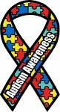
ALL ABOUT AUTISM

CAR, TRUCK, MOTORCYCLE SHOW & CRUISE-IN
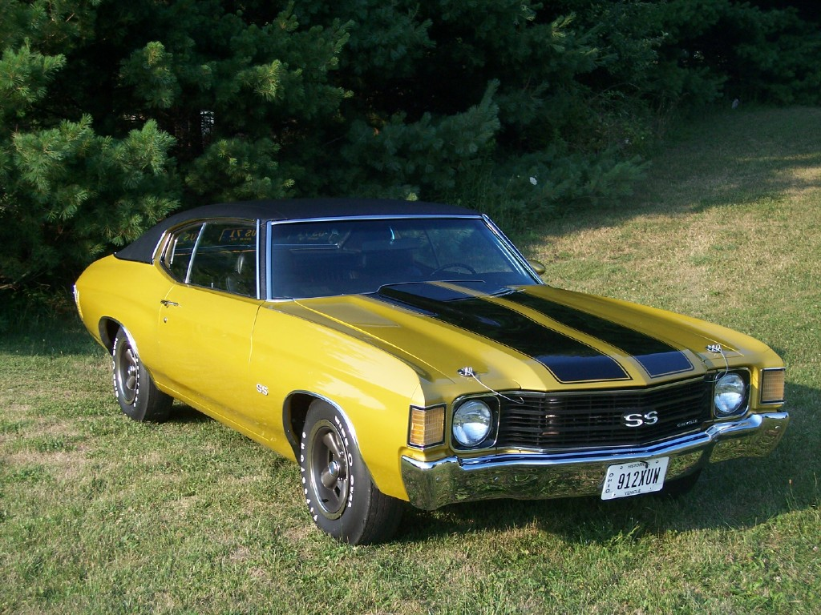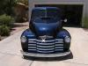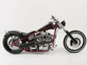

SECOND ANNUAL EVENT

100% OF PROCEEDS TO BENEFIT OAKSTONE ACADEMY, (CCDE) SCHOOL FOR CHILDREN WITH AUTISM SPECTRUM DISORDERS

WHEN: AUGUST 16, 2008 - 1:00 P.M. to 5:00 P.M. Registration Fee is $15.00

Registration begins @ 11:00 A.M. T-Shirts & Goodie Bags to the 1st 250 Registrants

WHERE: 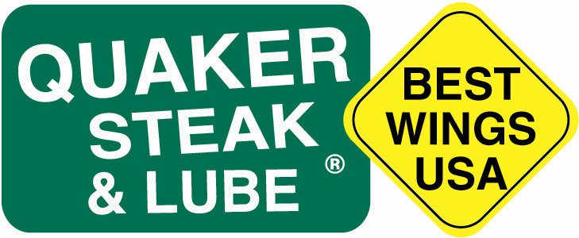8500 Lyra Drive, Columbus Ohio
www.quakersteakandlube.com
At the Intersection of Polaris Parkway and Lyra Drive

SPONSORED BY:

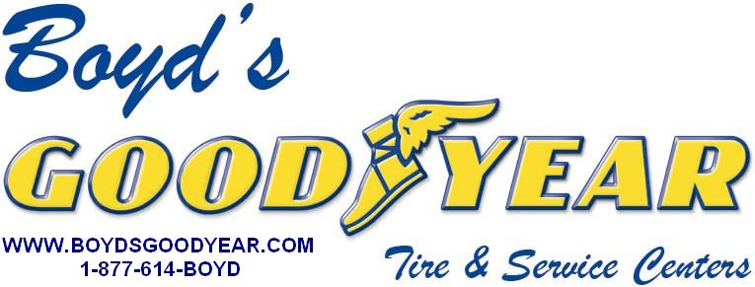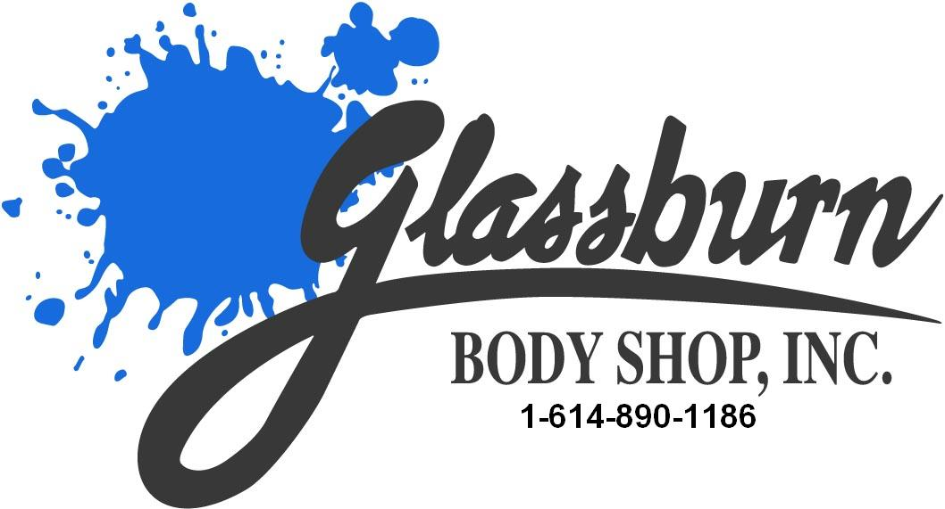

Music by “Six Pack Theory”, DJ, Karaoke, T-Shirts (1ST 250), Trophies (Top 50 Cars and Trucks. Top 20 Bikes ) Dash Plaques (1ST 250), Car Raffle, Silent Auction, Many Great Raffle Items, Great Food & Drinks, Peoples’ Choice Judging, Kids Activities, and Much More
MANY GREAT SILENT AUCTION AND RAFFLE ITEMS
NASCAR Tickets, Car Raffle, Set of Goodyear Tires, Rounds of Golf, Set of Dunlop Tires, Autographed Johnny Bench Lithograph, Limousine Ride, Oriental Rug, Race Memorabilia, Sports Memorabilia, Blackberry Phone, more to come…
* TO BE A SPONSOR, A VOLUNTEER, TO MAKE DONATIONS, OR HAVE ANY QUESTIONS ABOUT THE EVENT* PLEASE CALL MIKE HOOVER AT 614-580-7300 OR SEND AN E-MAIL TO
BOYDSGOODYEAR@AOL.COM
Or visit www.boydsgoodyear.com
DISCLAIMER:, BOYD’S GOODYEAR AND GLASSBURN’S BODY SHOP , AND QUAKER STEAK AND LUBE, ARE
NOT RESPONSIBLE FOR ACCIDENTS , AND / OR LOST, STOLEN OR DAMAGED ITEMS.
“MAKE A DIFFERENCE IN A CHILD’S LIFE”

OUR SPONSORS INCLUDE: (Thus Far)

BOYD’S GOODYEAR TIRE & SERVICE
GLASSBURN BODY SHOP
ALPHA GRAPHICS
AT&T
COLUMBUS DISTRIBUTING
SONIC’S RESTARAUNT
COLUMBUS ZOO
WORTHINGTON INDUSTRIES
AUTOBODY SUPPLY
SIX PACK THEORY
STARBUCKS
MIGHTY AUTO PARTS
A 2 Z WIRELESS
G & J PEPSI DISTRIBUTING
AMISH ORIGINAL FURNITURE
MAC TOOLS
SNAP-ON TOOLS
NAPA AUTO PARTS
DUPONT
3-M CORP
ADVANCE AUTO PARTS
MIMI’S CAFÉ
VALVOLINE
ENGLEFIELD OIL
LEVIS 4 FLOORS
GIAMMARCO’S PIZZA
GIANT EAGLE
PAT YOUNG SERVICE COMPANY
ELITE DETAILING SERVICES
KROGER’S
FROG BEAR WILD BOAR
MARS SNACK FOOD
THE HILTON AT POLARIS
THE CHEESECAKE FACTORY
ARAMARK UNIFORMS
DJ DAVE INC.
TEXAS ROADHOUSE

QUAKER STEAK AND LUBE
MIX 97.1 FM
LIFESTYLE FAMILY FITNESS
WHITE CASTLE CORPORATION
PEPSI
JEG’S HIGH PERFORMANCE
CHERYL & COMPANY
A.D. FARROW HARLEY DAVIDSON
THE RIGHT STUFF
BECKNER’S HOUSE OF RIDES
FIFTH THIRD BANK
DONATOS PIZZA
BYERS DUBLIN DODGE
CANNON’S TECH SUPPLY
PROCARE CARPET CLEANING
YOST TECH INC.
TECH SOURCE
WENDELL’S PUB
AROUND COLUMBUS ENTERTAINMENT
CAPITAL TIRE
MEIJER’S
VALPAK
NORTH CENTRAL TIRE
GLENROSS GOLF CLUB
CARQUEST AUTO PARTS
LUCKY PINSTRIPE . COM
GILLIS CHIROPRACTIC
SHAMROCK TOWING
ROD’S WESTERN PALACE
MID OHIO SUZUKI MT. VERNON
ALADDIN’S LIMOUSINES
BLACKHAWK GOLF COURSE
NET JETS
PRODUCE ONE
CARRABBA’S

